RocketMQ Deployment Guide

|  |  |  |
| --- | --- | --- |
| Version | Author | Date |
| 1.0 | Li Zhanhui | 2014/11/19 |

RocketMQ Deployment Guide 1

Deploy Name Server Cluster Manager Server 3

Deploy RocketMQ 4

Application Example 5

Contact 5

# **Deploy Name Server Cluster Manager Server**

1. Deployment Steps

Please refer to the following URL for detailed instructions:

<https://github.com/lizhanhui/rocketmq-nameserver-api>

1. Verification

After setting up per previous step, open your favorite browse go to <http://IP:8080>, you should see the following screen:

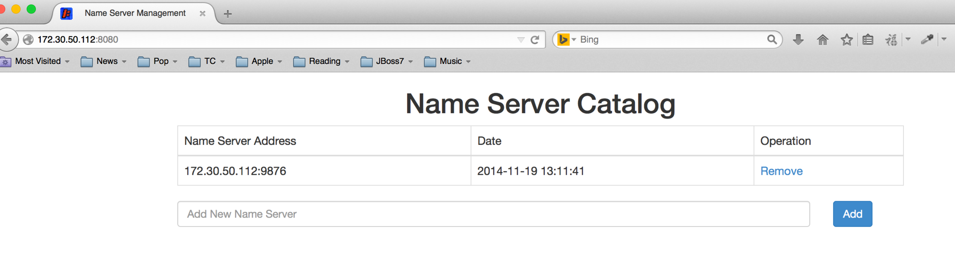

Go to the Name Server List API <http://IP:8080/rocketmq/nsaddr>, you should see something similar to the sequel:

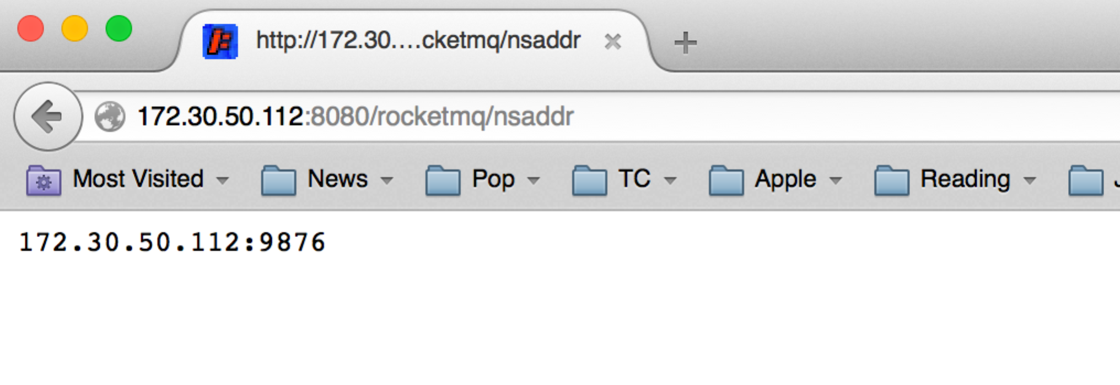

# **Deploy RocketMQ**

1. Clone Source Code

git clone https://github.com/lizhanhui/Alibaba_RocketMQ.git

1. Configure And Build

* Generate SSL Key/Certificate Pair

Use bin/ssl_key_cer.sh generate key/certificate pair

Add certificate to java trust key store as below

“sudo keytool -import -alias NDPMedia -file cer.pem -keystore ${JAVA_HOME}/jre/lib/security/cacerts”

* Configure SSL Settings

Refer to bin/tools.sh to enable SSL.

* sh install.sh

1. Deploy Name Server

* Edit System hosts file by adding the following entry, pointing to the Name Server Manager Site:

rocketmq.api IP

* Go to devenv/bin folder and execute the following command:

**sh start.sh nameserver**

1. Deploy Broker

Go to devenv/bin and execute the following command to start master sync broker:

**sh start.sh broker mast**

Execute the following command to start slave sync broker:

**sh start.sh broker master**

1. Verification

At devenv/bin, execute the following command, you should see the following cluster list once your broker is running correctly:

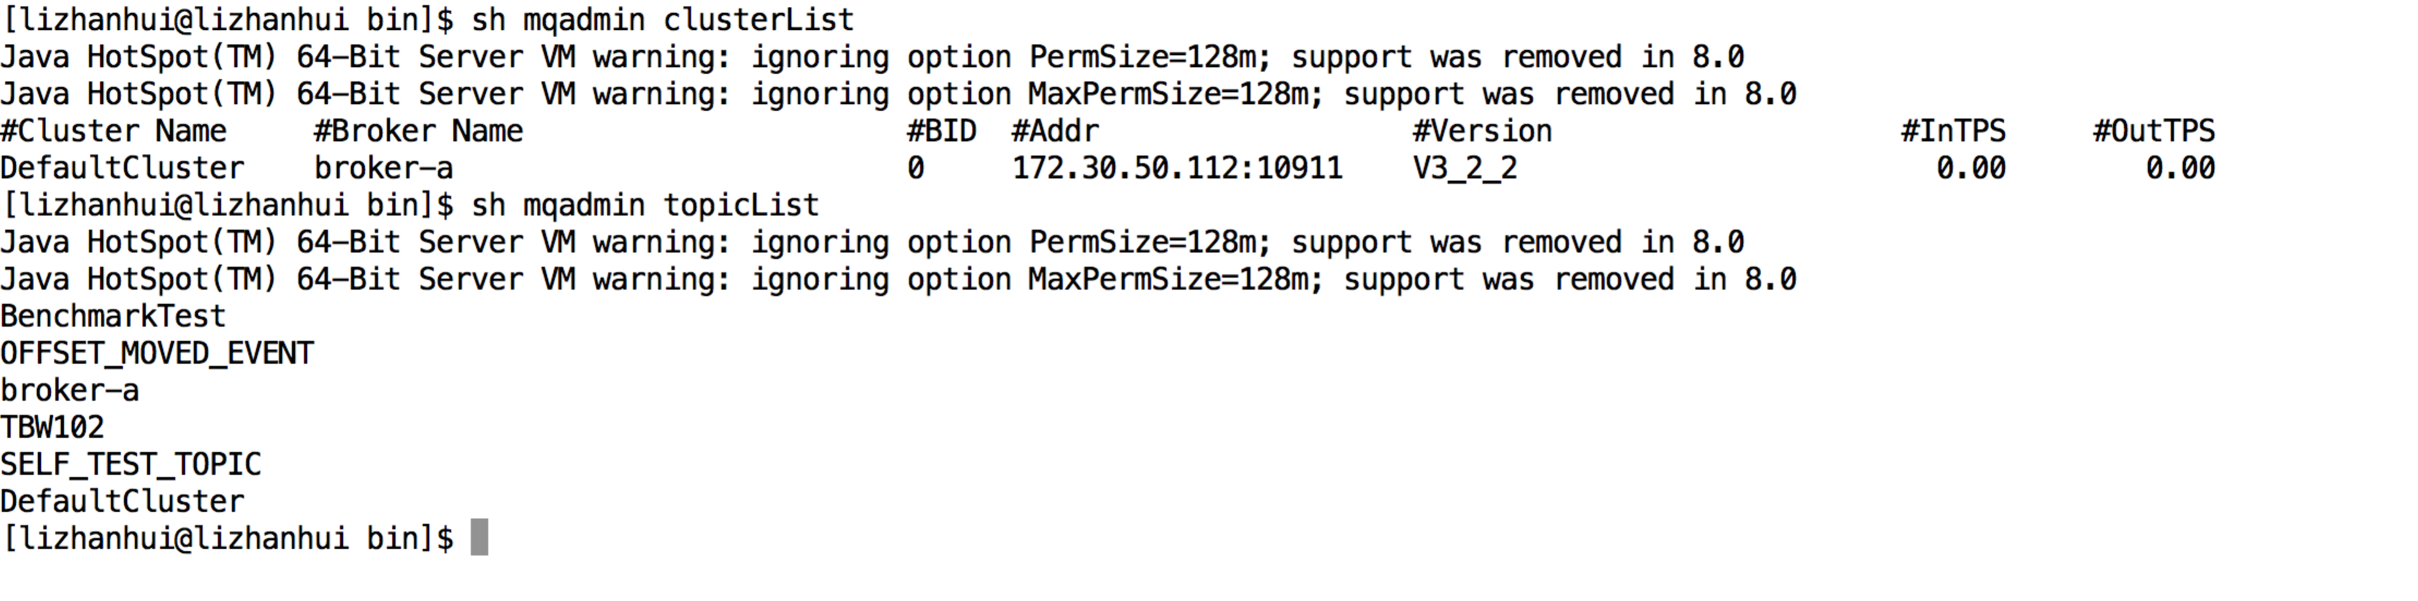

# **Application Example**

1. Producer
2. Consumer

# **Contact**

|  |  |
| --- | --- |
| Name | Email |
| Li Zhanhui | lizhanhui@gmail.com |